

Panther Parent Bulletin

Friday, Feb. 14 – 2 Hour Early Release

Monday, Feb. 17 – NO School

Wednesday, Feb. 26 – Progress Reports Sent Home

february 5, 2025

Royall Elementary school

Royall Intermediate School



**School Fundraiser**

We will kick off our one-time a year fundraiser on Friday, Feb. 7. Order forms are due on Monday, February 24. We encourage all families to participate in this event. Even selling 1 item helps the Royall students. Money donations are also accepted. The money that is raised pays for student field trips taken during the year.

Delivery date will be **Tuesday, March 18 from 3:15 p.m. to 5:00 p.m.** at the elementary school. Please enter through the old main entrance door #11 or door #8 by the dumpster. Both of these doors are off of Royall Avenue.

# Read Across America Week

## Monday, March 3

**Cozy Up with a Good Book!**

Wear sweatpants or pajama pants and a sweatshirt.

## Tuesday, March 4

**Giddy Up and Read!**

Wear your cowboy clothes and round up a good book.

## Wednesday, March 5

**Wacky Wednesday!**

Wear you wackiest, tackiest outfit.

## Thursday, March 6

**Team Up for Reading!**

Wear your favorite team’s jersey or shirt.

(It can be Royall)

## Friday, March 7

**Reading Makes Us Bright!**

Wear a Bright Colored Shirt.

**4 Year-Old Registration for Fall**

# Thurs., March 6

**Call – 462-2600 ext 2 to schedule a time.**

If you have a child that will be 4 on or before

Sept. 1, 2025, you and your child are invited to participate in the Royall Elementary Child Development Day on Thursday, March 6 from

8:00 a.m. – 3:00 p.m. at Elroy Public Library. There will be informational booths, refreshments, and gifts. It will take approximately 1 hour. This is when you are enrolling your child for 4 year-old kindergarten. We look forward to meeting you. Please call 462-2600 option 2 to make an appointment.

**All incoming 4 year-olds must register.**

**Pennies for the Pantry**

The 100th Day of School is Friday, February 7. Each student has been challenged to try and collect 100 pennies. The money will be donated to our local food pantry.

********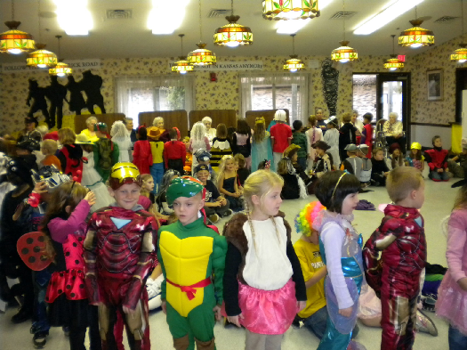 

**Upcoming Events**

**Friday, Feb. 14 – Pink or Red Day**

**Friday, Feb. 14 – 2 Hour Early Release**

**Monday, Feb. 17 – No School**

**Wed., Feb. 26 – Progress Reports Sent Home**

**Thursday, March 20 - 2 Hour Early Release**

**Friday, March 21 – No School**

**Tuesday, April 1 – Parent Teacher Conferences**

**Thursday, April 3 – Parent Teacher Conferences**

**Wed., April 16 - 2 Hour Early Release**

**April 17 – 21 – No School**

**Panther 3-on-3 Tournament**

The Panther 3-on-3 Basketball Tournament will be held on March 29 for boys and girls in 4th – 8th grade at Royall Schools. Please pick up your entry form in the school office or by contacting Chris Brown at 608-853-2059, or by emailing Chris at:

christine100brown@gmail.com

**ENTRY DEADLINE IS MARCH 13.**

**Warm Clothing ~ Outdoor Recess**

The weather is beginning to change. It is important to have your child dressed for cold weather. The students go outside for recess everyday unless the temperature or wind chill is below 0 degrees, or it is raining. Students are encouraged to bring warm clothes to school including hat, mittens, snow pants and boots. All items should be marked with name or initials. If your child is in need of items, please call the school.

**Royall Fundraiser (1x year)**

Friday Feb. 7 – 24

**Fundraiser Delivery**

Tuesday, March 18

3:15 p.m. – 5:00 p.m.

Elementary Cafeteria

* Please use door #11, the old main entrance, or door #8 by the dumpster. Both doors are off of Royall Avenue.

**School Closing Information**

The school will be using the Skylert System to notify parents of school delays or cancellations. School closing and delays will also be on the following radio and television stations between 6:15 a.m. and 7:30 a.m..

**Television Radio**

**Madison** Ch. 3 WCOW 97.1 FM

Ch. 27 WRJC 92.1 FM

1270 AM

**La Crosse** Ch. 8

Ch. 19

* **If there is a school closing or delay and you do not receive an automated message from the school, please let the school know.**

Reminders

february 5, 2025

PLACE LOGO OR

COMPANY NAME HERE

PLACE PHOTO HERE,

OTHERWISE DELETE BOX

PLACE PHOTO HERE,

OTHERWISE DELETE BOX